**NEWS RELEASE**

**2015 Memorial Day Parade Route Change Due to Lake Street Closure**

Due to construction on Lake Street and the closure of the Lake Street bridge, the 2015 Memorial Day Parade will have a different route on Monday, May 25th. The route will start at the corner of Lake Street and Oxford Avenue, travel east on Lake Street to 2nd Avenue, travel south on 2nd Avenue to Chippewa Street, and travel east on Chippewa Street to Owen Park. The 2015 parade route is shown in yellow below.

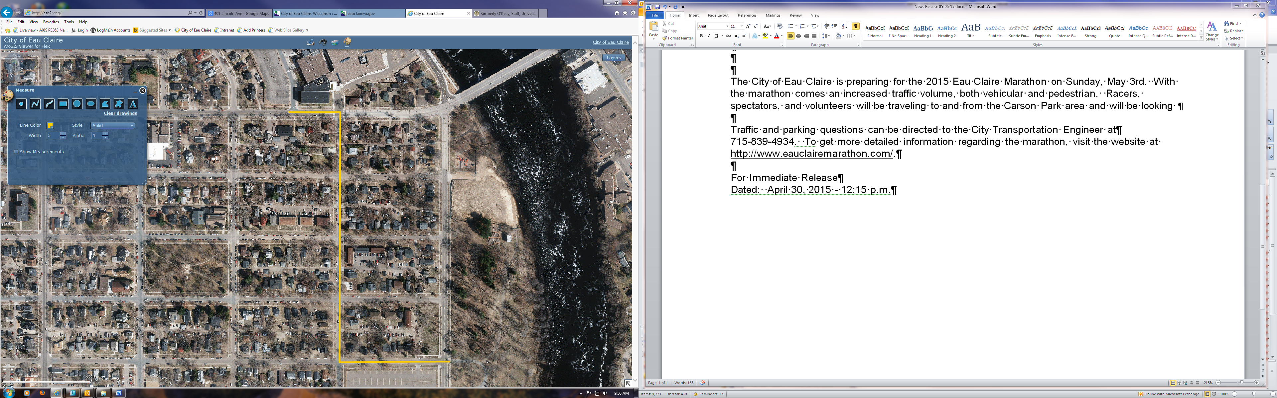

CONSTRUCTION

**1ST AVE**

**2ND AVE**

**CHIPPEWA ST**

**LAKE ST**

Parking will be restricted along the parade route for the parade. Questions regarding the parade can be directed to the Ron Martin of the Eau Claire Patriotic Council at

715.379.5583.

For Immediate Release

Dated: May 7, 2015